Admission Policy
TSA is open to admission for students irrespective of communities, cultures or nationalities. It welcomes all types of education seekers to access and benefit from its enriching academic life. However, TSA maintains a standard format for admission. We understand you are keen to bless your children with high quality education at TSA, we suggest you to a acquaint yourself with admission policy before applying. To ensure an equal opportunity to all the aspiring parents like you, we grant admission to students in our global learning ecosystem on the fulfilment of the terms and procedures detailed herein.
TSA admits students based on the fulfilment of the terms and procedures mentioned herein and in accordance with our assessment system supervised by the members of our Admissions Committee. The final decision to admit a student, however, lies jointly with the Principals.
Admissions are subject to availability of seats, and the school management reserves the right to communicate it as and when they deem fit.
Our new academic year begins in the first week of April every year and ends in the last week of March of the succeeding year.
Under the perspective of security and healthcare polices, TSA might refuse the grant of admission to students who are expelled from other schools on proven ground sexual harassment and misconduct, substance abuse, ragging, bullying, racial discrimination, promoting fundamentalism and/or to students who at the time of applying have pre-identified learning difficulties and deficiencies specified below
Down syndrome
Permanent blindness, deafness and/or voice disorders
Chronic depression
Psychosis (Schizophrenia)
Chronic life-threatening ailments
Parents must ensure that their child/children meet the age criteria. The eligible age for admission on the 1st of April for different grades and programmes is as follows:
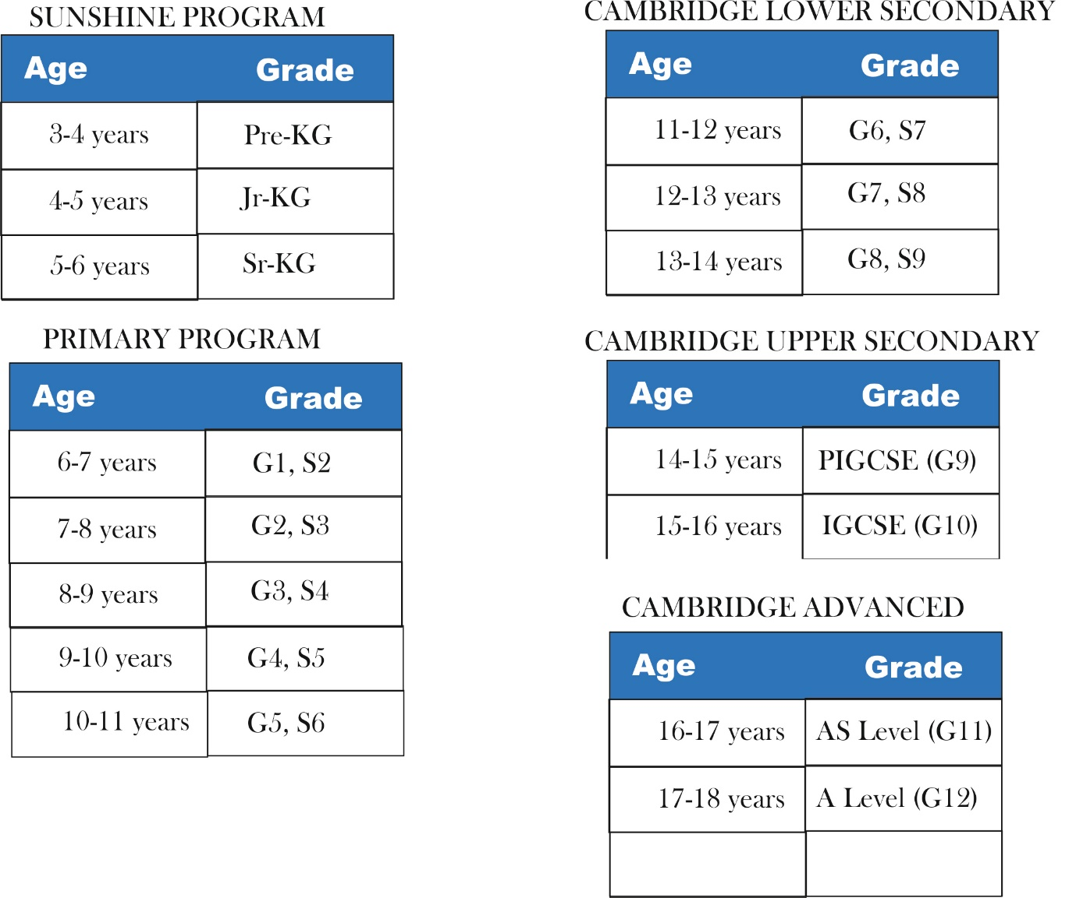

- On discovering that admission granted to a student was on misleading details and/or fabricated documents provided at the time of applying, we will blacklist the student and invalidate his/her admission with immediate effect.
- Admission, if granted, will be subject to strict adherence to all the policies and procedures instituted and followed at TSA; any subversion or compromise will result in admission cancellation.
- The school management reserves the right to amend and change the present-day policies, procedures, and curriculum if considered essential for the progress and development of students.
- Acceptance of admission will indicate parents’ consent to all the policies and procedures followed at TSA.

